Project Design Phase

**Solution Architecture**

|  |  |
| --- | --- |
| Date: | 24 June 2025 |
| Team ID: | LTVIP2025TMID47029 |
| Project Name: | Enchanted Wings: Marvels of Butterfly Species |
| Maximum Marks: | 4 Marks |

# Solution Overview

This project aims to automate butterfly species identification using deep learning. The system uses transfer learning with the VGG16 model to classify butterfly images into 75 different species. A Flask-based web interface allows users to upload butterfly images and receive real-time predictions.

# Functional Description

The system comprises the following modules:

* + Image Preprocessing Module – resizes, scales, and normalizes input images.
  + DL Model Module – a trained VGG16 model that performs classification.
  + Evaluation Module – validates the model against test data.
  + Web Interface – built using Flask, allows users to upload images and view predictions.
  + Class Mapping – displays readable species names instead of numerical labels.

# Architecture Diagram

The below architecture diagram illustrates the end-to-end workflow of the butterfly classification system:

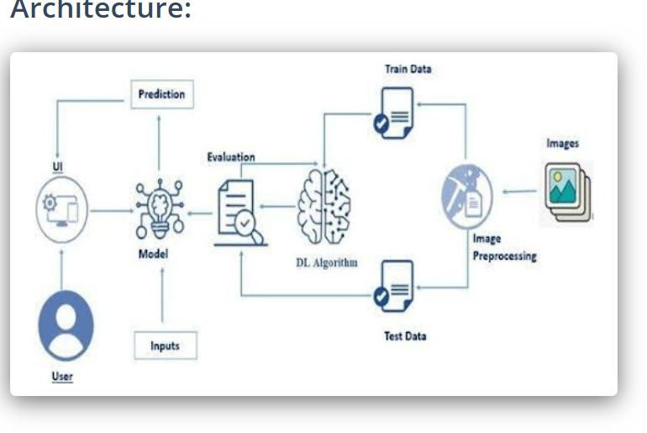

# Component Explanation

* + User Interface: Provides an image upload feature for users.
  + Input Layer: Receives input image from the user.
  + Image Preprocessing: Resizes image to 224x224 pixels and scales pixel values.
  + DL Algorithm: Uses a VGG16 model fine-tuned on 75 butterfly species.
  + Evaluation: Model performance is validated using separate test data.
  + Prediction: Model predicts class index which is mapped to species

name.

# Conclusion

This solution enables efficient and accessible butterfly species identification through AI. It benefits conservation efforts, educational research, and biodiversity monitoring.